Azure: it’s a cloud provider which provide IT resources on rent.

Azure Resource Manager (ARM) is the deployment and management service provided by Microsoft Azure for managing resources such as virtual machines, storage accounts, databases, and networking components within the Azure cloud environment. ARM allows users to create, update, and delete resources in a declarative manner, meaning you define the desired state of your infrastructure, and ARM handles the provisioning and management to achieve that state.

ARM Template: ARM (Azure Resource Manager) template is a block of code that defines the infrastructure and configuration for your project. These templates use a declarative syntax to let you define your deployment in the form of JSON (JavaScript Object Notation) files.

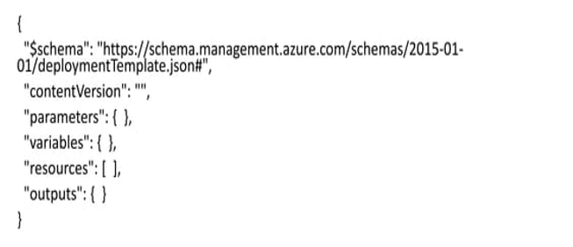

With ARM template we can apply validation into Azure resource. [Like Resource group name should be between 3-24 characters]

There are many ways to create infrastructure in azure like CLI, Web, Terraform and many other tools. ARM template is native tool by which we can create infrastructure in Azure.

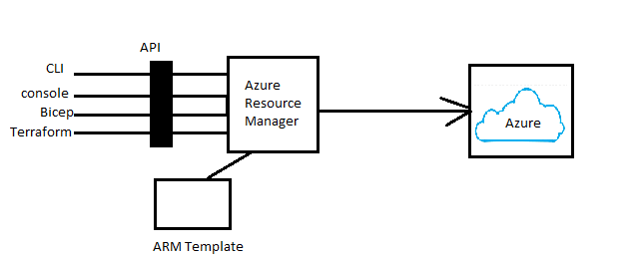

Step1: Install visual studio editor in system.

Link: <https://code.visualstudio.com/>

Visual Studio Code, also commonly referred to as VS Code, is a source-code editor developed by Microsoft for Windows, Linux, macOS and web browsers. Features include support for debugging, syntax highlighting, intelligent code completion, snippets, code refactoring, and embedded version control with Git

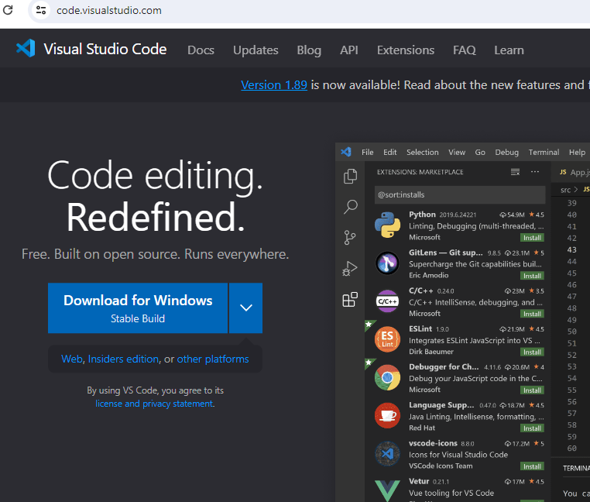

Step2: Install plugin to enhance functionality

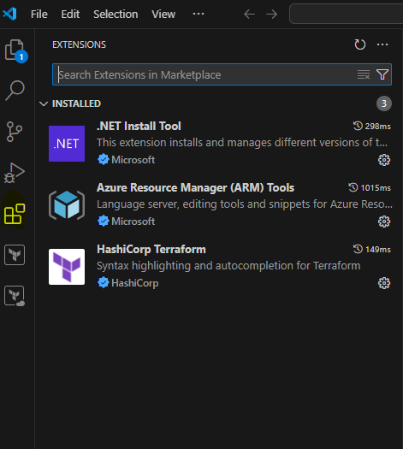

Example1: Create terraform template for creating resource group in Azure.

Example2: Create terraform template to create Linux virtual machine.

Solution: Open visual studio code then type arm! Then click on enter. Post that under resource click on the resource you want to create.

Link: <https://learn.microsoft.com/en-us/azure/azure-resource-manager/templates/syntax>

Flow: Schema validate what you have written is correct or not, Resource is that you want to create, parameter is when you want to pass runtime variable, variable is when you are using enter multiple time.

Output: What you want get public ip after creation of resource.

Function: Used to solve the complex logic.